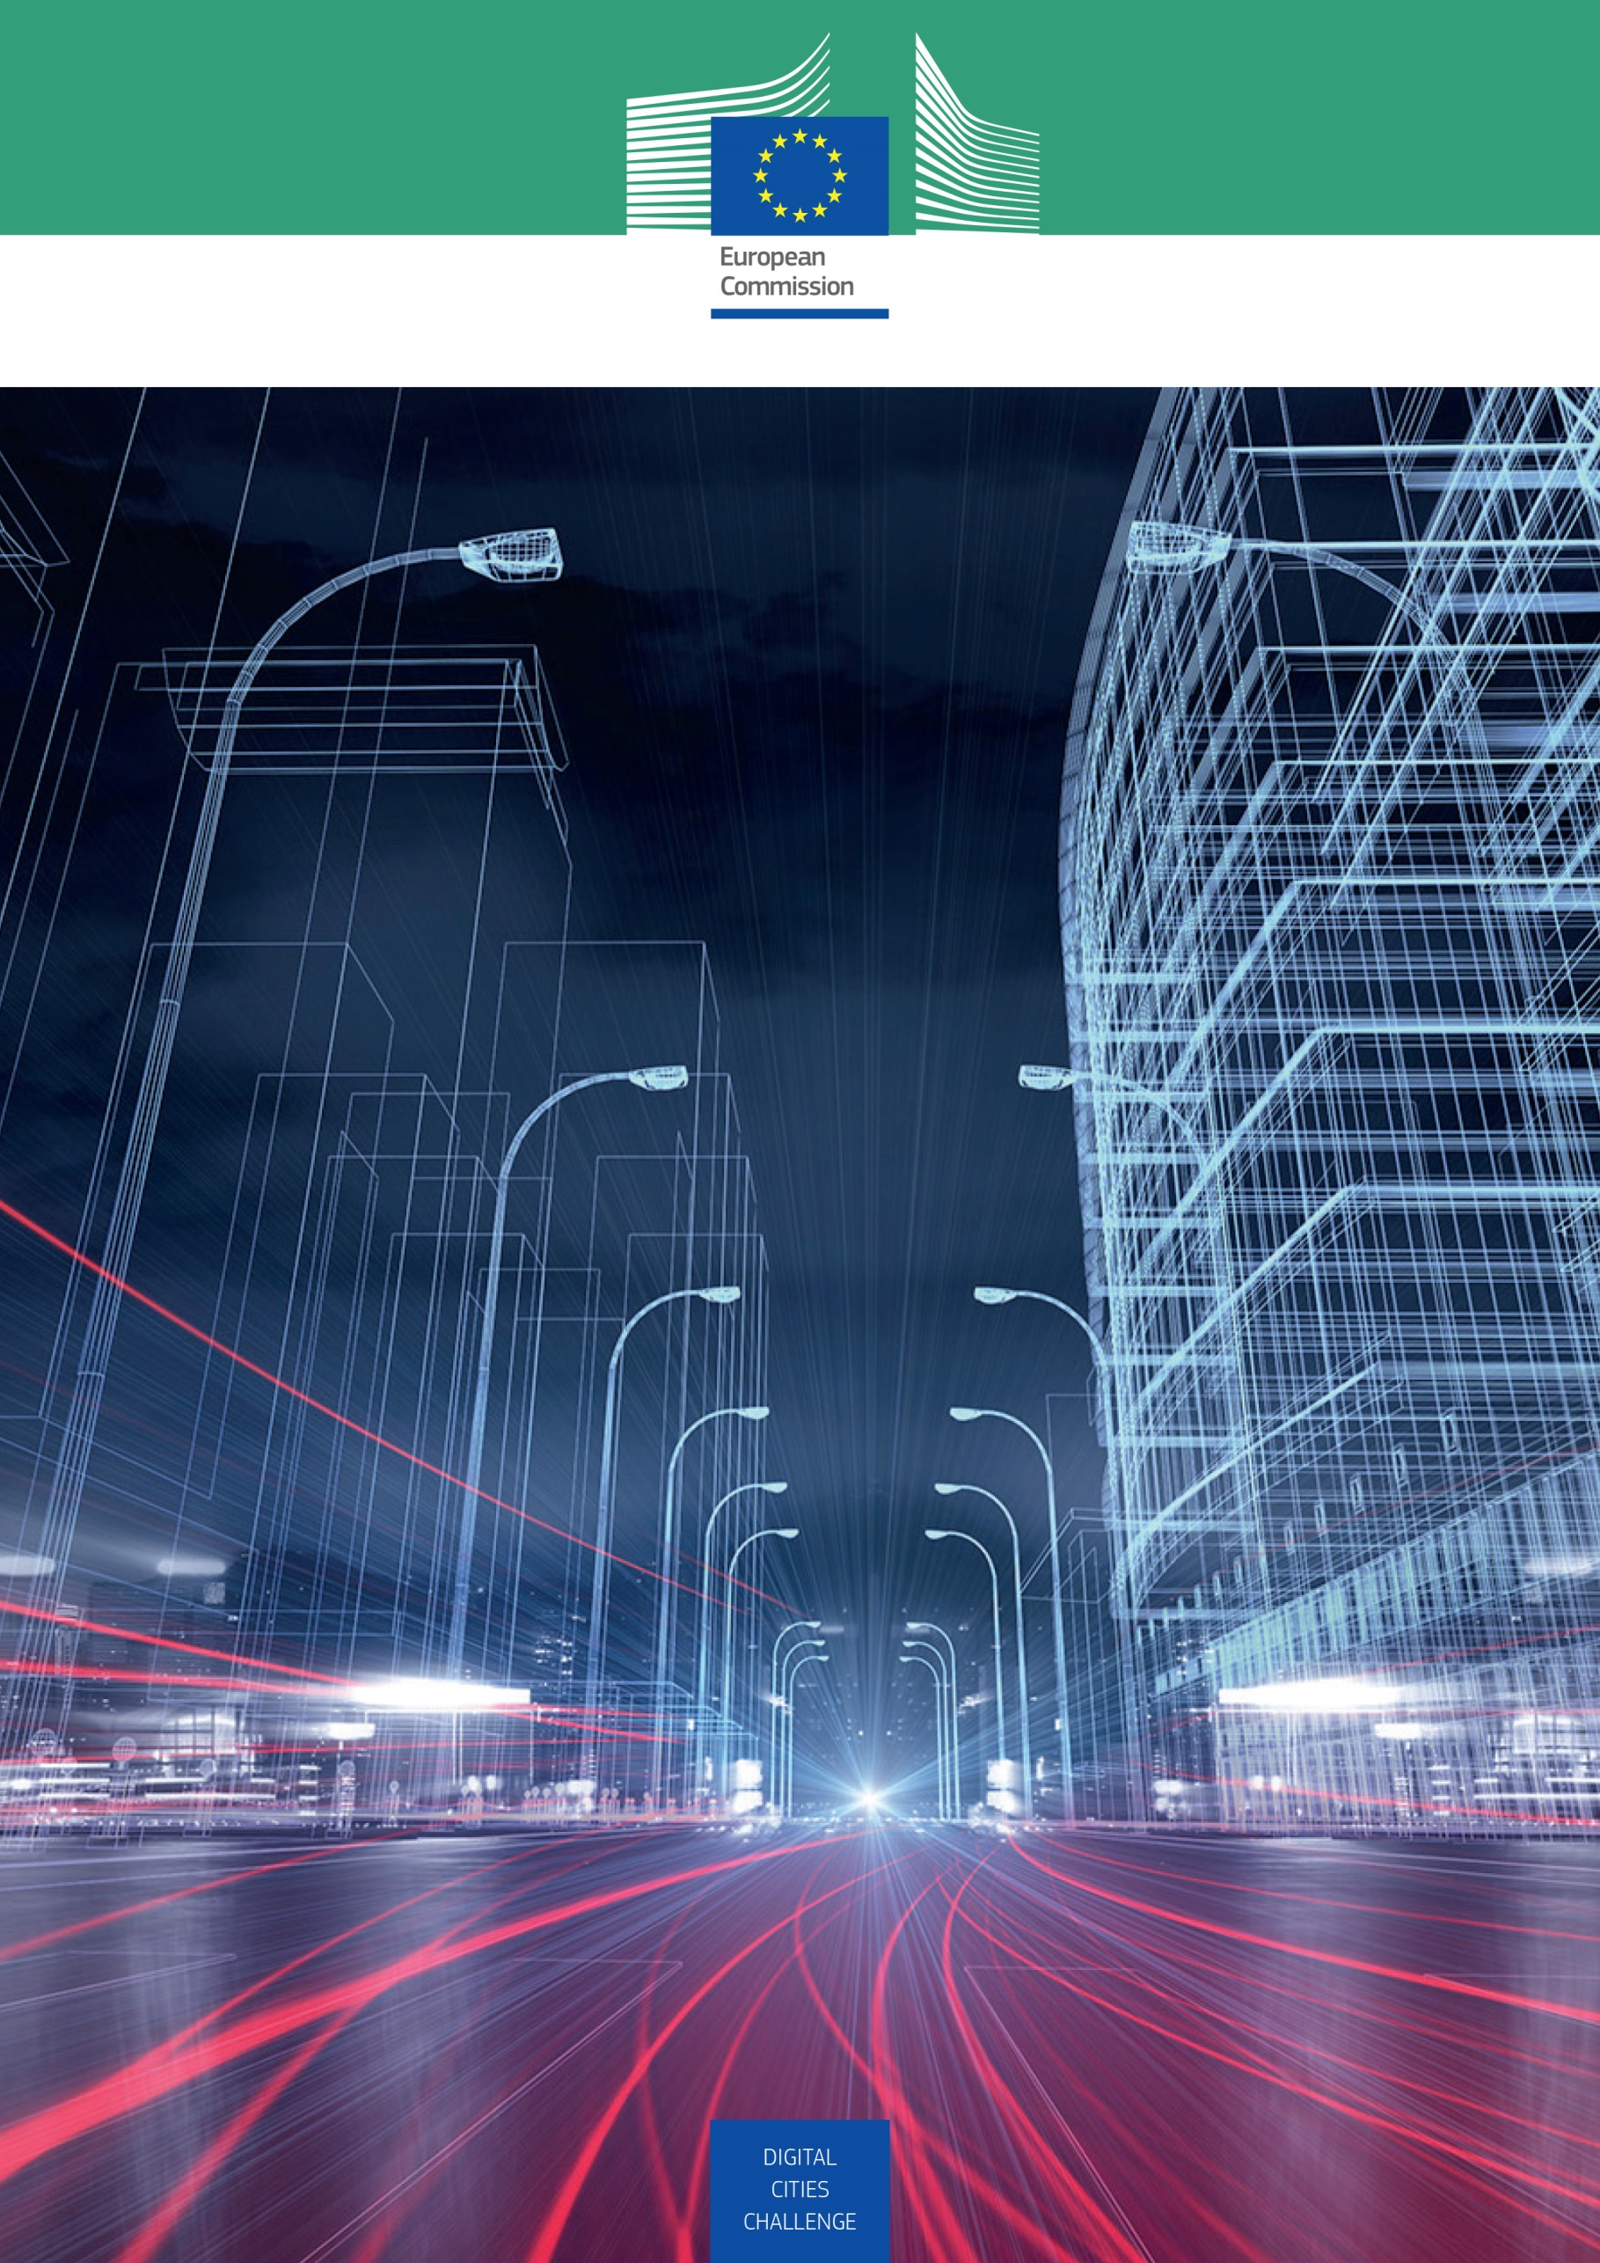
October 2017
DIGITAL
Cities Challenge

Expression of
interest template

Expression
of interest template

You must use the structure of the present template in order to prepare your Expression of Interest. You are kindly re- quested not to modify or delete any sections.
General Instructions on the template
1
- You may delete all the parts of instructions including instructions written into brackets and in Italics format ([italics]).
- The maximum total length of sections 1 to 4 of your Expression of Interest shall not exceed 12 pages in total (including figures and tables) with the following page limits for each section:

Section of the template | Recommended page number
Section 1 – Presentation of the city and its ecosystem | 4 pages
Section 2 – Digital ambition | 3 pages
Section 3 – Impacts | 3 pages
Section 4 – Staff and other assets | 2 pages

- The minimum allowed font size is 10. Please use the same page margins as in this template

START PAGE COUNT
Structure of the Expression of Interest:
2
1. Presentation of the city and its ecosystem
1.1 Presentation of the city
1.2 Facts and figures
1.3 Innovation ecosystem
2. Digital ambition
2.1 Policies involving digital transformation dimensions
2.2 Participation in projects related to digital transformation (regional, national and European)
2.3 Timeline
3. Impacts
3.1 Achieved / expected impacts
4. Staff and other assets
4.1 Team of professionals
4.2 Stakeholders involvement
4.3 Resources

STOP PAGE COUNT
Annex I: Letter of intent of participation of stakeholders (not mandatory)
Annex II: Additional documentation to support the EoI (not mandatory)

City
Organisation
Responsible (Name, Role, email)
Expression
of interest
Academy seminar
Indicate if you could host an Academy seminar (Yes / No)

Presentation of the city and its ecosystem
[Length: 4 pages maximum]
1
[In this section, the applicant should present and describe the city and its ecosystem with relevant characteristics, facts and figures.]

  - Presentation of the city
[Brief presentation of your city, including the main characteristics: geographic, demographic, economic…]

  - Facts and figures
[Please fill in the table by providing both the quantitative and qualitative data / information. Add lines to the table if appropriate.]

Data | Result
City Population
Metropolitan area population (e.g. an area consisting of a densely populated urban core and its less-populated surrounding territories, sharing industry, infrastructure, and housing)
Average annual population growth during the last five years (since 2013)
Employment rate (ratio of employed to working age population from 15 to 64 years)
Main economic sectors

  - Innovation ecosystem
[Present the stakeholders involved, and their potential to help the city in its digital transformation and industrial modernisation. Detail organisations/partners involved in delivering digital transformation projects across the city. This could include local authority, public sector, private sector, voluntary sector, academia and any other relevant organisations or stakeholder groups as appropriate.]

Digital Ambition
[Length: 3 pages maximum]

2
[The objective of this section is to have an overview of the current state of your city regarding the integration of advanced technologies and the ambition in this field. In this section, the applicant should describe the current policies involving digital priorities (e.g. smart specialisation, environmental strategy, digital skills programme…). In addition, participation in on-going programmes and projects in the field of digitalisation at regional, national and European levels should be described.]

  - Policies involving digital transformation dimensions
[Describe in detail the on-going / planned policies, notably strategic documents and measures in support of Digital Transformation of your city. Please identify the general objectives, key priorities, and targeted sectors, etc. Any policy is relevant as long as it includes one or more measures promoting the further use of digital technologies at the city level.
Policies supporting digital transformation may cover, amongst others, the following fields:
- Smart specialisation strategy;
- Innovation and industry 4.0 policies;
- Sustainable growth;
- Circular economy;
- Energy efficiency (e.g. smart grids, public lighting)
- Environmental strategy;
- Digital skills programmes;
- Support to digital entrepreneurship;
- Citizen’s empowerment].

  - Participation in projects related to digital transformation (regional, national and European)
[Describe in detail the on-going projects that support the Digital Transformation of the city.]

  - Timeline
[Describe in detail the activities that you plan to carry out in order to implement the digital objectives of your city. Applicants are asked to present a detailed work plan on the basis of the on-going policies involving digital transformation dimensions.
You can use tables (see an example below) to present an overview of your work plan, specifying the activities, responsible managing authority as well as the allocated time for their execution (start / end date).]

Title of activities | Responsible managing authority | Start date | End date

Impacts
[Length: 3 pages maximum]

3
  - Achieved / expected impacts
[Describe here the impact of policies, programmes and projects in your city]
Examples of impacts cover, amongst others, the following:
- Collaboration with local actors, building an innovation ecosystem;
- Further engagement and participation of citizens;
- Significant uptake/or increased use of digital and other advanced technologies (e.g. bio- or nano-materials, 3D printing etc.);
- Increased employment in sectors or companies that have taken up advanced technologies and/or applied innovative business models;
- Improved e-services provided to citizens;
- Enhanced resource efficiency, environmental benefits;
- Better digital and cyber-physical infrastructures at city level (e.g. access to wifi, sensorisation of electricity and water supply, sensorisation to manage air pollution, mobility, etc.).

In case of on-going policies, programmes and projects for which is too early to demonstrate the long-term results and / or the newly planned ones, please describe the expected impacts (e.g. City A plans to develop an e-platform facilitating car and bike sharing among citizens at city level. The promotion of these low-carbon shared mobility solutions will lead to a more efficient mobility, and a reduction of car pollution.]

Staff and other assets
[Length: 2 pages maximum]

4
  - Team of professionals
[Provide a short description and relevant experience of the personnel to be involved in the execution of the work as well as a description of his / her intended function in the execution of the advisory services to be provided within the Digital Cities Challenge initiative.]

  - Stakeholders involvement
[Provide a short description of organisations with which you are planning to collaborate in order to co-design / operationalise the strategy supporting digital transformation. Indicate how you will engage your city’s stakeholders (citizens, entrepreneurs, relevant organisations…) in the Digital Cities Challenge.]

  - Resources
[Please identify and describe the available resources that you could build on to implement the strategy supporting digital transformation (e.g. in-kind support, shared resources from other organisations, financial plans, grants or other, if relevant).]

5
- Annex I: Letter of intent of participation of stakeholders (not mandatory)
- Annex II: Additional documentation to support the expression of interest (not mandatory)

